**Classical Approach:**

We started by reading the images as grayscale (value of the pixel between 0 and 1), then we tried the 3 classical approaches mentioned in the document.

1. **Image differencing:**

We get the difference of the two arrays (images in time 1 and images in time 2), so the values now between 0 and 1.

Then we tried a number of thresholds [0.05,0.1,0.15,0.2,0.25,0.3,0.35,0.4,0.45,0.5]

And we found this result

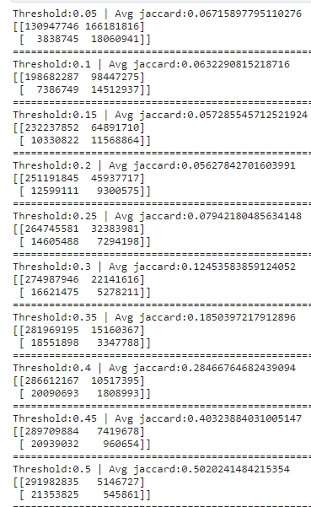

We think that the reason of high jaccard for high thresholds is the most of the dataset is no change so when we predict there is no change we add 1 for the array of the jaccard but this is not a general case in the real test set so we can choose a threshold of 0.3 to be more general.